Ender’s Game, by Orson Scott Card:
Final Assessment (Weight x 4 = 100pts+20bonus)
(*DO NOT WRITE ON THIS TEST – ANSWER ON ANSWER SHEET ONLY – SHORT RESPONSE ON BACK OF ANSWER SHEET*)
READ EACH QUESTION AND ANSWER CAREFULLY BEFORE MAKING YOUR FINAL DECISION!!! Good Luck!
RL.7.1: I can refer to the text to find several examples to support my thoughts and inferences about a story.
- Who did Ender get into a fight with after having his monitor removed?
- Graff
- Stilson
- Bernard
- Bonzo
- What happened to Bernard on the launch ship?
- Ender broke his arm because he was repeatedly hitting Ender on the head.
- Ender told the other Launchies Bernard was proof that chips travel in space.
- Graff told the rest of the launch Bernard was the only boy on the ship with any brains.
- He and Alai became friends and plotted against Ender.
- How did Ender defeat the Giant in the fantasy game?
- He broke both glasses and strangled the Giant.
- He finally picked the correct drink, and the Giant let him pass into Fairyland.
- He jumped onto the Giant’s head and poured the poison into the Giant’s mouth.
- He kicked over the glasses and burrowed into the Giant’s eye socket.
- How are Ender, Peter, and Valentine all similar?
- They are all child geniuses.
- They are all dangerous and cruel.
- They are all Thirds.
- They are all traveling to colonize the bugger worlds.
- What would likely have changed if the humans and buggers could talk with one another?
- The buggers would have known the humans were intelligent and attacked Earth first during the 3rd Invasion.
- The buggers would have known the humans were intelligent and not tried to colonize Earth, avoiding the 2nd Invasion.
- The buggers would never have built starships to explore the universe.
- The humans would have won the 1st Invasion.
RL.7.2: I can infer the theme or message of a story by analyzing details from the text.
- What theme statement best represents how games are important in the story?
- Games can be a healthy outlet for violent behavior.
- Games can be used as a way to build real-world skills.
- Games can cloud our judgement of reality.
- All of the above theme statements are shown in Ender’s Game.

- What theme would best describe Ender’s relationships with Stilson and Bonzo?
- Beauty is only skin deep.
- Brains versus Brawn
- Slow and steady wins the race.
- All of the above themes are shown in Ender’s relationships with Stilson and Bonzo.
- Which major event from the story develops the theme statement “Communication is the key to resolution.”?
- Ender discovers his Command School training was the actual 3rd Invasion against the bugger home world.
- Ender finds out Bernard was the boy whose arm he broke on the launch ship.
- Graff reveals to Ender the reason humans and buggers are at war is because they can’t talk to each other.
- Peter becomes Hegemon of Earth.
- Decide if “Good vs. Evil” is an appropriate theme to identify Ender’s relationship with the buggers. Why or why not?
- No, because the buggers are not evil. They were looking to colonize and, since they and humans were unable to communicate, did not think humans were intelligent, so began killing humans similar to how we would clear out a roach infestation.
- No, because the buggers are too much like insects to be held responsible for their actions.
- Yes, because humans are the only intelligent species of value, and anyone who opposes the human race must be evil.
- Yes, because the hive queen continued to try and colonize Earth even after she learned that humans were intelligent like herself.
- Which of the following elements of the story supports the theme, “Don’t judge a book by its cover.”?
- Ender is a scrawny 6-year-old super-genius strategist and tactician.
- Graff tells Ender he is not his friend, but he actually does care for Ender and considers him a friend.
- Peter is a dangerous and cruel boy but pretends to be innocent and harmless around adults.
- All of the above elements support the theme, “Don’t judge a book by its cover.”
RL.7.2: I can give an unbiased summary of a story.
- Which of the following details would you include in a summary of Ender’s fight with Bonzo in the shower?
- Bonzo found out Ender was using Bean in a special unit to implement tasks separate from the rest of the army.
- Bonzo was angry with Ender for winning the battle against Salamander and using Dragon’s smallest soldier to point out his faults as a commander.
- Bonzo was from Cartagena, Spain: Earth.
- Bonzo was secretly in love with Ender’s sister, Valentine.

- How would you summarize Valentine’s involvement in the war?
- Valentine and Peter started a land war against the Polemarch and the Russians so they could later assume control of power on Earth once the bugger war was over.
- Valentine helped the I.F. refocus Ender by writing him a letter and visiting with him at the cabin on Earth.
- Valentine negotiated a meeting between Ender and the cocooned Hive Queen in order to devise a plan where the Formics (buggers) could be brought back to live peacefully with humans.
- Valentine was participating in Battle School training in a facility on Earth to improve her skills and join Ender at Command School.
- Which of the following best summarizes Mazer Rackham’s relationship with Ender?
- Rackham is Ender’s enemy. He is in charge of programming the war simulations that Ender and his army fight in Command School.
- Rackham is the hero from the 2nd Formic Invasion and Ender’s trusted teacher and companion. In their short time together, Rackham trains Ender in his specialties of combat in hopes to create in Ender the commander needed to defeat the Formics (buggers).
- Rackham is the hero from the 2nd Formic Invasion and has been time-sustained in light speed to secretively help Ender strategize against the buggers during the actual 3rd Invasion against the bugger home world. Rackham convinces Ender he has programed simulated battle situations in order to bring him along in his training, when in actuality, he has Ender fighting the 3rd Invasion with every new battle.
- Rackham is the hero of the 2nd Invasion. Ender studies his battle over and over to learn everything he can about the strategies Rackham used against the Formics (buggers) during the attack. Although Rackham died in the battle and is unable to answer Ender’s questions, Ender learns everything he needs to know about Rackham’s strategies in order to finally defeat his enemy.
- Sequence the following events into chronological order.
- Ender cries.
- Ender gets his monitor removed.
- Ender tells Stilson’s gang, “Just remember what I do to people who try to hurt me.”
- Stilson’s gang corners Ender into a fight.
a) 1423 b) 2431
c) 2314 d) 4231
- Sequence the following events into chronological order.
- Ender defeats Bonzo in battle.
- Bonzo attacks Ender in the bathroom.
- Ender disobeys Bonzo and saves their army from defeat.
- Bonzo tells Ender he cannot practice with his launch group during free play.
a) 1234 b) 2431
c) 4312 d) 3214

RL.7.3: I can explain how elements of a story work together.
- What are the three different locations the story takes place, and Ender’s position at each location?
- Cartagena, Spain – Friend, Battle School – Commander, Greensboro, North Carolina – Brother
- Earth - Student, Battle School - Soldier, Eros – Commander
- Earth – Third, Treason – Mueller, Eros – Commander
- School – Student, Home – Brother/Son, Lusitania – Minister of Colonization
- At the end of the story, Ender makes a promise to the hive queen. Which of Ender’s characteristics contribute most to this resolution of the story?
- Ability to be dangerous although he is not cruel by nature.
- Leadership qualities and ability to command large groups of untrained soldiers.
- Physical agility and ability to out strategize his opponent.
- Understanding of human nature, empathy, and compassion.
- Explain how Ender feels about his enemy once he knows he is able to completely destroy them?
- He allows his compassion for his enemy to completely debilitate his ability to make decisions, causing him to falter in the wake of battle.
- He feels a sense of pride in being able to finally understand his enemy well enough to overcome them, and an even greater desire to be victorious in battle.
- He immediately becomes indifferent to the survival of his enemy in battle. Life or death, once he completely understands his enemy, it is only the victory that matters in the end.
- Once he understands his enemy well enough to destroy them, in that moment he also loves them.
- How did Valentine’s letter change Ender’s mind about continuing in the Battle School program?
- She reminded him he was nothing like Peter and even though he was excellent at defeating his enemy he was not cruel.
- She told Ender if he did not go back into training that everyone would thing he was exactly like Peter. She was afraid he would not be able to handle the pressure, so begged him to do what the I.F. asked of him.
- She told Ender of her secret identity as Demosthenes, and assured him she could help him win the war.
- She told Ender that Peter had become Hegemon of Earth and the only way to keep him from destroying the human race was to win the battle against the Formics (buggers).

- How did Bonzo holding Ender back from battle affect Ender as a soldier?
- Ender was unable to practice on the holographic games in the game room, which would have given him a great advantage once he graduated to Command School and began playing battles on the simulator.
- It caused Ender to drop to the bottom of the soldiers prized “Efficiency List”.
- It caused Ender to question his ability to perform in battle and made Ender worry he would not be good enough to trade to another army in the long run.
- It kept Ender from learning and growing as a soldier in how to maneuver in battle, but it also allowed Ender to study Bonzo’s strategies as a commander.
RL.7.7: I can compare and contrast the written version of a story with its multimedia version.
- Identify which event in the book is left out of the movie that helps the reader understand Ender’s relationship with Bernard.
- The Launchy hitting Ender repeatedly on the head and Ender accidently breaking the boy’s arm when he retaliated in order to get the boy to quit.
- The launch group’s first practice session when Ender uses Alai as a bridge between himself and Bernard.
- Both A and B are correct.
- Neither A or B are correct.
- How was the environment in which Bean first met Ender changed in the movie?
- Bean was Alai’s best friend in the book, and Ender used Alai to become Bean’s friend; but, in the movie, Bean was not introduced until Ender met his squadron leaders in Command School.
- Bean was not introduced to Ender until he arrived at Command School in the book, whereas he was part of the launch group in the movie.
- In the book, Bean was an elite group toon leader in Rabbit Army who had asked his commander, Rose deNose, to trade for Ender specifically; however, in the movie, Bean was introduced as one of Ender’s fellow Launchies.
- In the movie Bean was introduced at the beginning as part of Ender’s launch group, where in the book he was introduced as a new Launchy assigned to Ender when he took command of Dragon Army.
- How was the environment in which Dink first met Ender changed in the movie?
- Dink was Ender’s commander in Dragon Army in the movie; where in the book he was Rat Army’s elite unit toon leader under Rose de Nose and had asked for Ender specifically.
- Dink was placed as a toon leader in Salamander Army under Bonzo in the movie, where in the book, he was Rat Army’s elite unit toon leader under Rose de Nose and had asked for Ender specifically.
- In the movie, Dink was Bonzo’s elite toon leader, and in the book he was the boy Ender had challenged in the game room.
- In the movie, Dink was Salamander Army’s elite toon leader under the command of Bonzo; whereas in the book, Dink was Petra’s boyfriend and one of Bonzo’s henchmen that helped corner Ender in the shower.
- The conversation between Graff and Ender on their way to Command School on Eros at the end of Chapter 13 was left out of the movie. What important information does the reader learn during this portion of the text?
- During the conversation, Graff tells Ender he murdered both Stilson and Bonzo.
- During this conversation, the Graff tells Ender he is actually leading the 3rd Invasion against the Formic (bugger) home world.
- Graff tells Ender the buggers communicate telepathically and that the entire war has been caused because the two species cannot communicate with each other.
- Graff tells Ender the Hive Queen has left behind a cocooned Hive Queen to allow her species to be reborn when the humans are able to do so safely.
- What part of the story was left out in the film version that helps us to understand Valentine and Peter’s involvement in the war?
- Ender has secretly been working with Valentine and Peter to insert Peter into the Hegemony as Hegemon of Earth and Valentine as the new Minister of Colonization following the end of the Formic (bugger) war.
- In the book, Valentine and Peter travel to Battle School to help Graff talk Ender into resuming his duties as a soldier. Graff knows the only way to convince Ender to go on is to remind him of how similar he is to both his brother and sister, dangerous and compassionate, convince Ender he is a capable commander like Peter, but not cruel, and compassionate enough like Valentine he will keep his soldiers safe.
- Peter and Valentine have taken on pseudonyms of Locke and Demosthenes to sway opinion in order to prepare for the political fallout after the bugger war has ended.
- Through the Fantasy Game, Ender learns that Peter has plans to take over Earth and Valentine needs Ender’s help to prevent Peter from becoming an evil world dictator.

- RL.7.2 & RL.7.3 - 20pt Bonus Short Response: Answer on the back of your test answer sheet or attach your response on a sheet of notebook paper in at least 3-5 complete, quality sentences. Be sure to restate the prompt. Pay attention to your power verb, “DESCRIBE”, and your number commands, “ONE way”. Be sure your response meets all requirements. Steal as many words from the prompt as you can in order to make sure you are answering the correct question and utilizing academic language in your response. (20pts Possible: 5 pts restate/structure, 5 pts power verb, 5 pts number commands, 5 pts academic language):

Throughout the book the authority figures (I.F. and instructors/teachers) manipulate Ender. At Command School Ender is tested on his ability to command by playing in mock battles against the buggers. DESCRIBE ONE way this was another manipulation by the authority figures, and ONE way this might have changed the plotline if Ender were aware of this manipulation beforehand.
Ender’s Game Final Assessment (KEY)

- B
- A
- D
- A
- B
- D
- B
- C
- A
- D
- B
- B
- D
- B
- C
- B
- D
- D
- A
- D
- A
- D
- B
- C
- C

26.) Throughout the book the authority figures (I.F. and instructors/teachers) manipulate Ender. At Command School Ender is tested on his ability to command by playing in mock battles against the buggers. DESCRIBE ONE way this was another manipulation by the authority figures, and ONE way this might have changed the plotline if Ender were aware of this manipulation beforehand.
Responses will vary: The mock battles are not simulations but the actual 3rd Invations. Ender likely would not have used Dr. Device on the Formic home planet had he known the military ships were maned by actual humans and the planet was inhabited by billions of Formic lives.

20pts Possible:
5 pts restate/structure – Restates prompt and response is at least 3-5 quality sentences in length.
5 pts power verb – Uses descriptive language to respond to prompt.
5 pts number commands – Completes number commands (one way each).
5 pts academic language – Uses at least five of the underlined phrases in response.

Name:________________________
Date:______________
Period:____________

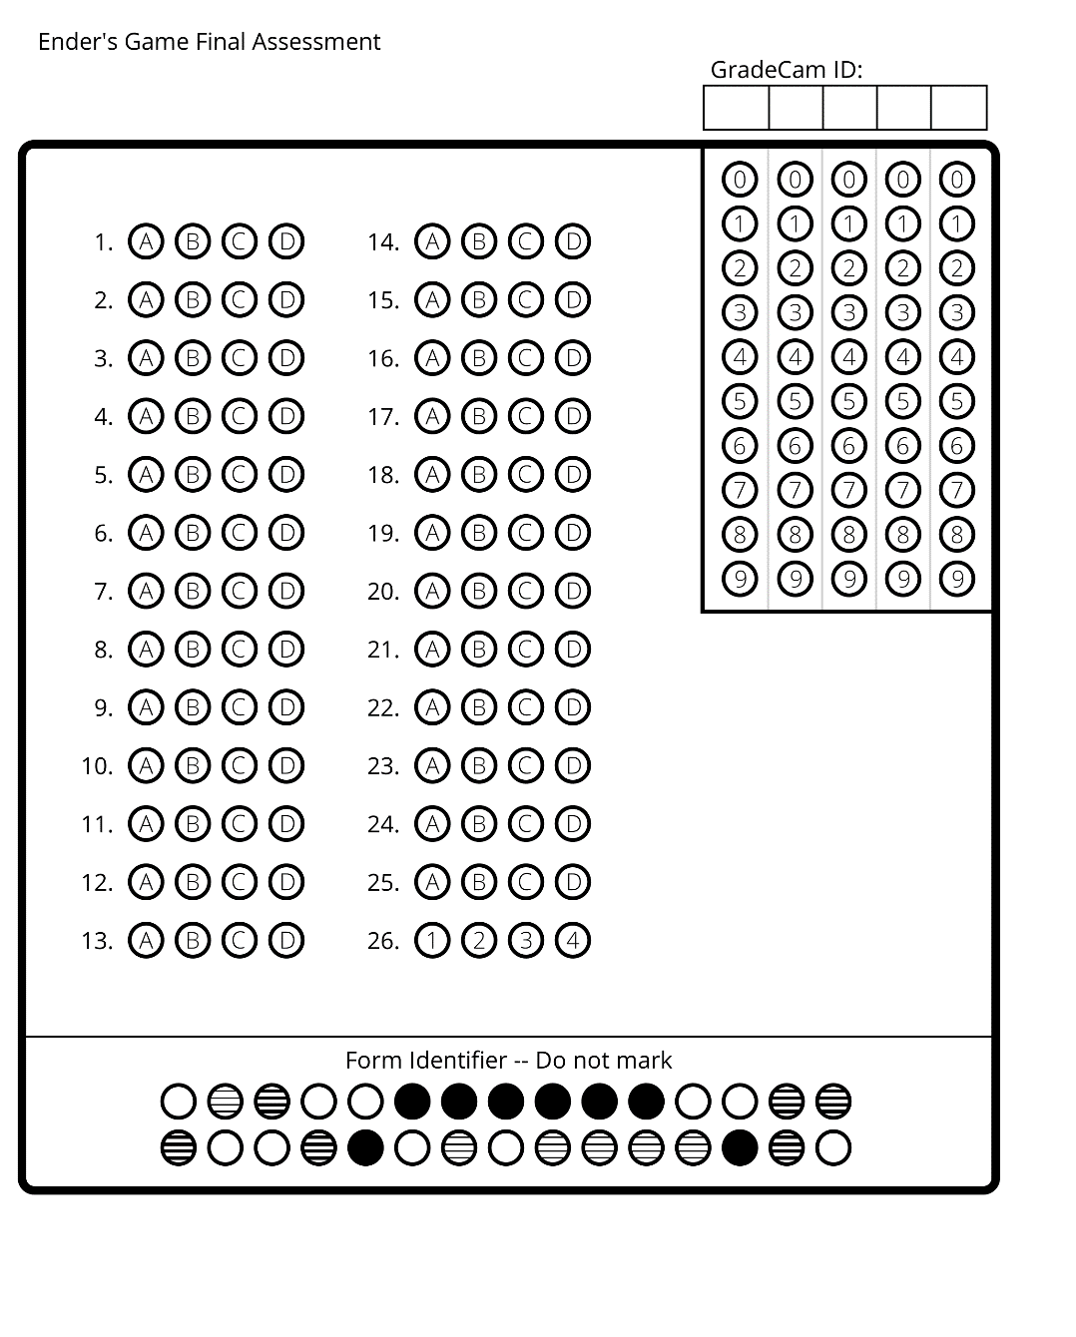
Name:________________________
Date:_____________
Period:___________

